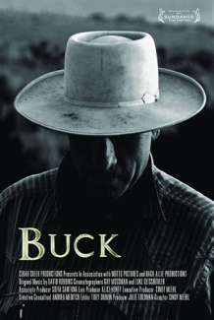
Save the Date!!

Friday March 9, 2012

The San Luis Obispo County Child Abuse Prevention Council
presents the heartwarming film
BUCK
at the San Luis Obispo International Film Festival.

Please join us for an evening of fun, prizes and inspiration.

If you’d like to get involved in this inaugural fundraiser for SLO-CAP, please email Natalie Stets at nstets@slocap.org
Benefitting 