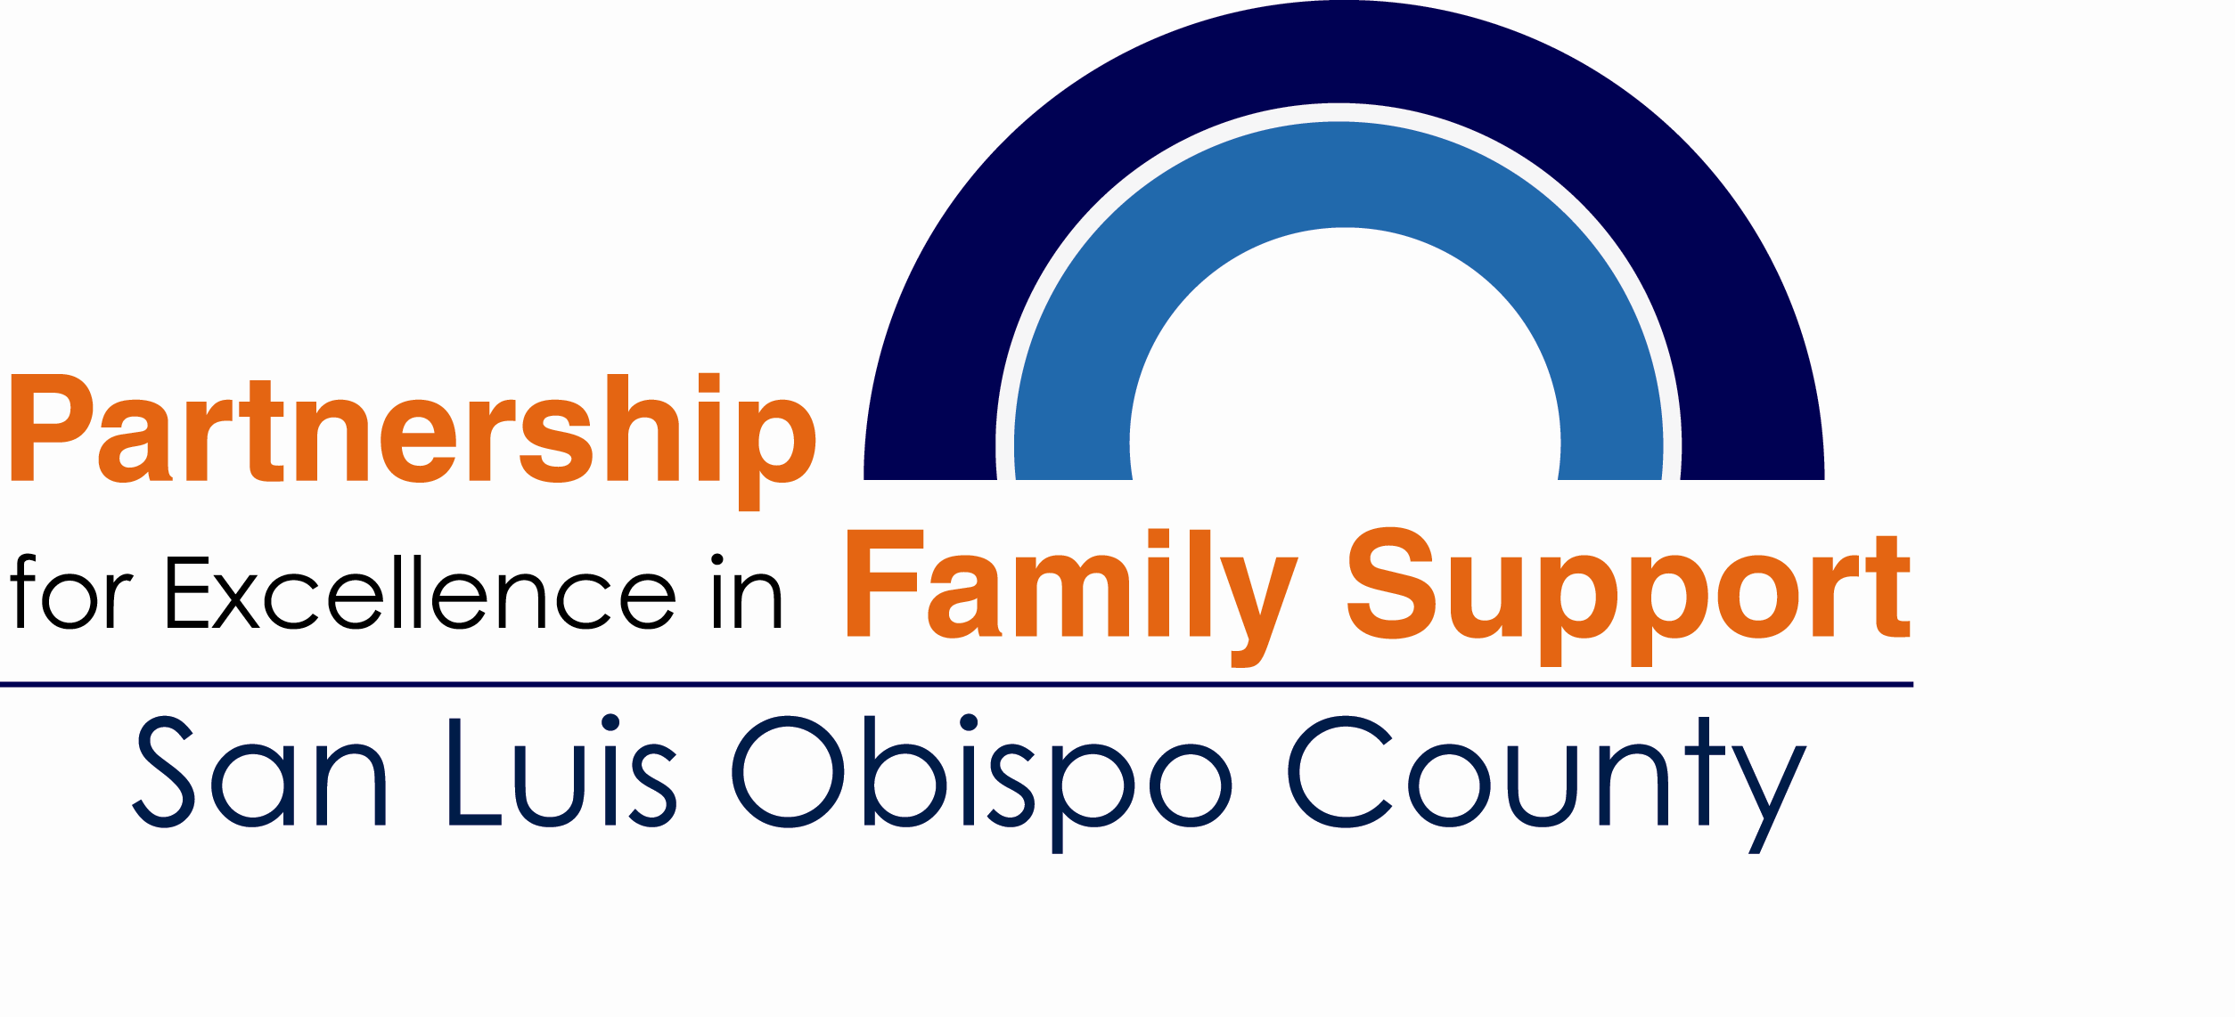
Staff Development Standards

In 2011 the Professional Development Standards Committee designed this Training Guide to provide a systematic approach to training, allowing the Educator/Advocate to develop and track accomplishments and promote professional development. This serves as a portfolio to highlight completed trainings and map out future trainings, based on the Professional Goals Worksheet.
We recommend a binder system to house the Training Guide as a tool for standardizing the skill sets required by Family Advocates and Parent Educators. Also, It can serve as a foundation for formulating development strategies depending on the Advocates experience.
The Training Guide Binder should include the following components:
- Family Advocate/Parent Educator Training Guide-A list of foundational trainings and Skill Development trainings that are recommended for professional development
- Professional Goals Worksheet-This worksheet reflects a planned approach to guiding staff to set goals for one year.
- Training Announcements/Flyers and Training Certificates-These handouts document completed trainings and provide details regarding content.
- Professional Certifications/Credentials- This tab is an area to store certificates, professional accomplishments, permits and credentials.

